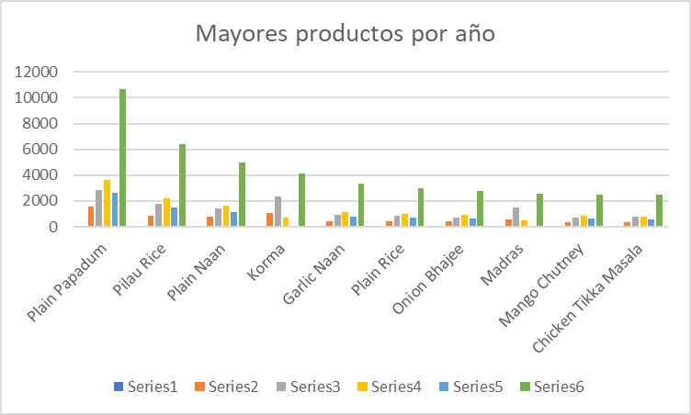

 | 2015 | 2016 | 2017 | 2018 | 2019 | Grand Total
Row Labels
Plain Papadum |  | 1570 | 2846 | 3612 | 2620 | 10648
Pilau Rice |  | 858 | 1782 | 2228 | 1499 | 6367
Plain Naan |  | 770 | 1433 | 1619 | 1161 | 4983
Korma |  | 1083 | 2322 | 705 |  | 4110
Garlic Naan |  | 447 | 943 | 1158 | 770 | 3318
Plain Rice |  | 436 | 872 | 979 | 677 | 2964
Onion Bhajee |  | 431 | 740 | 909 | 669 | 2749
Madras |  | 561 | 1491 | 501 |  | 2553
Mango Chutney |  | 332 | 695 | 851 | 626 | 2504
Chicken Tikka Masala |  | 346 | 751 | 806 | 570 | 2473
